7.24: From 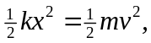 the relations between m, v, k and x are
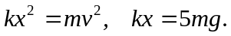
Dividing the first by the second gives 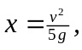 and substituting this into the second gives 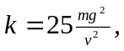 so a) & b),
